- The broad shape of today's UK Budget was largely as expected, but the scale of the increases in current spending, capital spending, and taxation were larger than we had anticipated. Fiscal policy will be tightened over the next five years by less than the previous government planned.
- Changes to the fiscal rules are a positive step in terms of encouraging investment, and in our view could have a bigger impact on potential output than the Office for Budget Responsibility estimates. But the new investment plans are still low by international standards.
- The OBR thinks today's measures will offer a solid boost to real GDP growth in the near-term. But we think the impact will be smaller, given how public sector output is measured and that some of the spending increase will fund higher wage settlements.
- On current spending, the new plans look more credible. But the small margin for error against the borrowing rule leaves the government at risk of needing to increase taxes again in the future.
Chancellor Rachel Reeves had to walk a tightrope when presenting Labour's first Budget in 14 years today. She needed to boost day-to-day funding for UK's public services and increase government investment levels to support economic growth and improve the country's decaying infrastructure. But the demands for extra spending had to be balanced with the need to maintain fiscal credibility and address the UK's poor debt dynamics.
The result was a large package of measures that will result in substantial increases in current spending, capital spending, and taxation compared with the plans inherited from the previous government (Chart 1). Today's announcement was intended to set the course for Labour's five-year parliamentary term. The Chancellor's pledge to only hold one major fiscal event each year and set spending plans for at least three years were also designed to promote stability. But with the multi-year review of departmental spending due in spring and a wafer-thin margin for error against the borrowing rule, the plan will almost certainly need to be tweaked as the parliament progresses.
Chart 1: The Chancellor announced a net loosening of policy of nearly £40bn a year
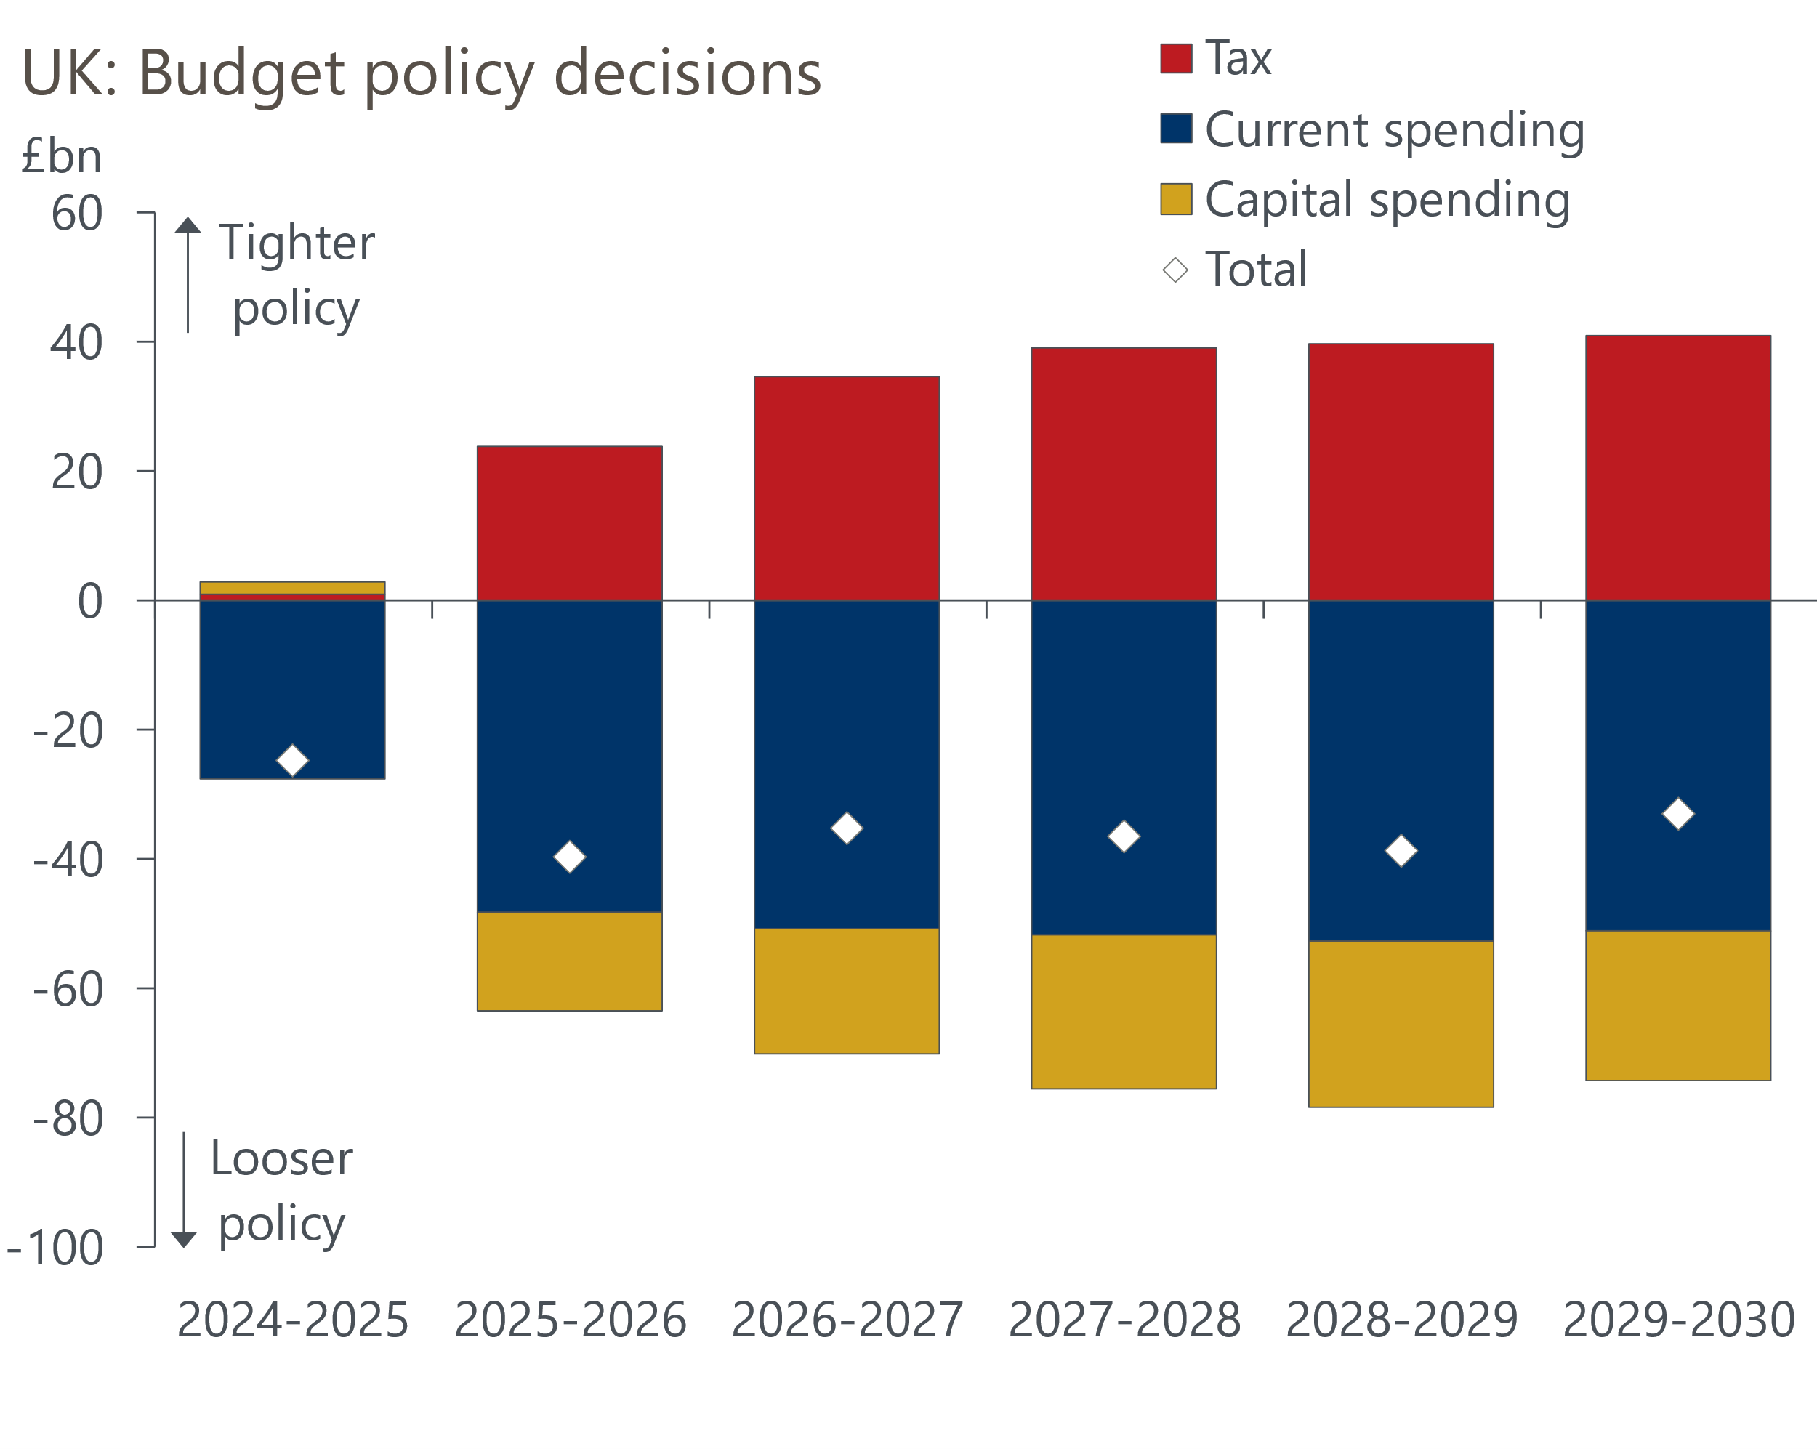
Source: HM Treasury

Looser fiscal rules are more growth-friendly
The government's approach was framed by two new fiscal rules. The new borrowing rule – which the Chancellor branded as the 'stability rule' – was part of Labour's election manifesto. The government will target a balanced current budget (i.e., day-to-day spending matched to government revenue), rather than setting a limit for the broader public sector net borrowing measure.
Before the election, the Chancellor had hinted she would keep the deeply flawed debt rule inherited from her predecessor. But she subsequently changed tack, arguing that the rule needed to take account of the benefits of investment as well as the costs. We set out the various options in a recent note, and today the Chancellor announced that she will target a falling ratio of public sector net financial liabilities to GDP, which the government is now referring to as net financial debt.
This is a broader measure than public sector net debt that includes illiquid financial assets (e.g. student loans to be repaid) and some other financial liabilities (including funded public sector pension liabilities). The Office for Budget Responsibility's new forecasts show that the change in the debt measure has increased the headroom by £22bn (0.6% of GDP; Chart 2).
Chart 2: The new debt rule offers more scope for investment
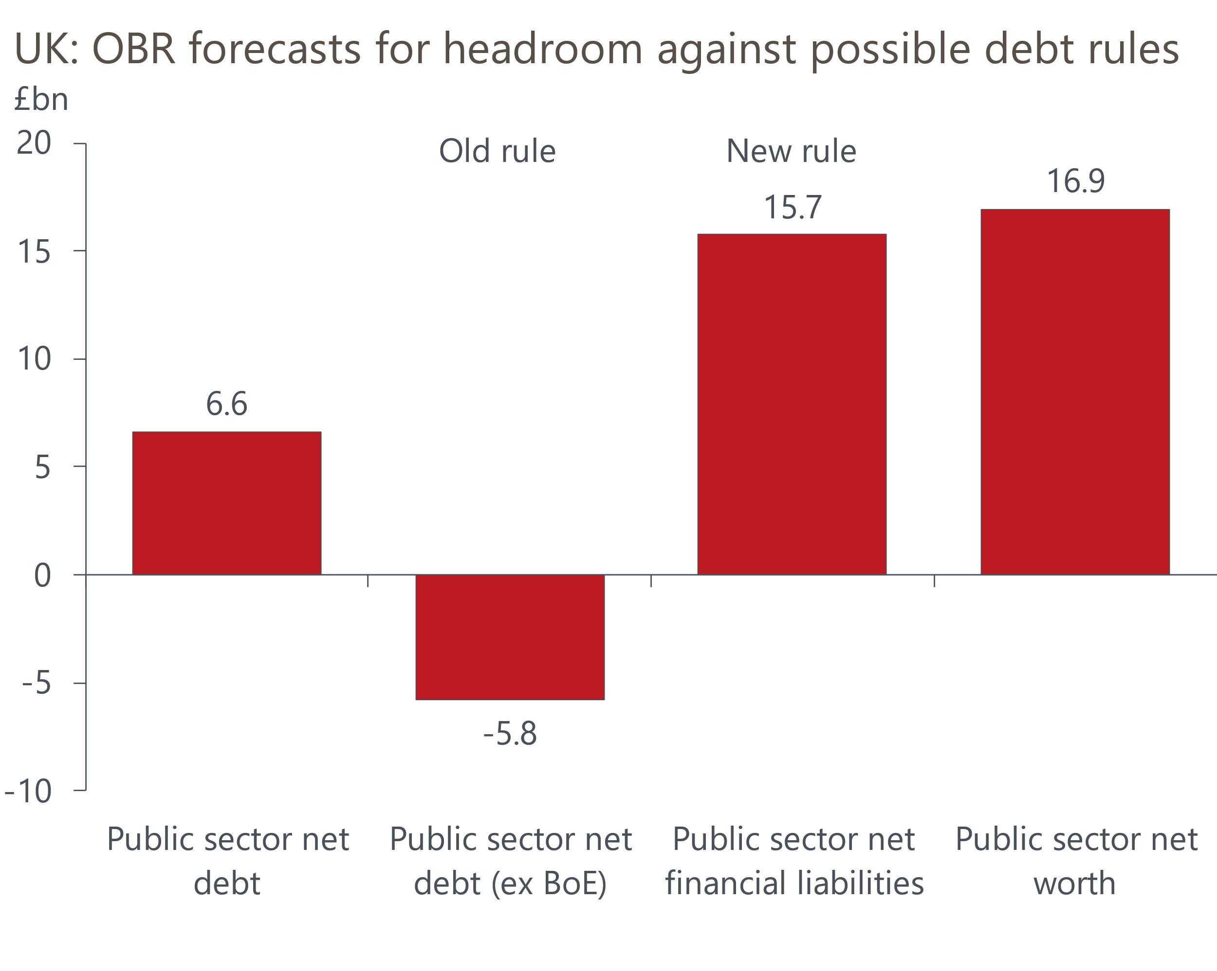
Source: Office for Budget Responsibility
The rules are currently evaluated for 2029-2030, the same five-year horizon used by her predecessor. But when that year becomes the third year of the forecast, the rules will be assessed on a rolling three-year basis. The shorter time horizon is something that we've previously advocated and should help to reinforce credibility in the government's fiscal plans.
The extra headroom has allowed the Chancellor to ramp up government investment by £23bn (0.7% of GDP) in 2029-2030, compared with the previous plans. But those plans had involved investment dropping to a 13-year low as a share of GDP (Chart 3). The new plans show a much smaller drop in the ratio of investment to GDP, keeping the level above the average of the past 20 years. However, capital spending will still be relatively low by international standards.
Chart 3: Investment is now planned to stabilise close to current levels
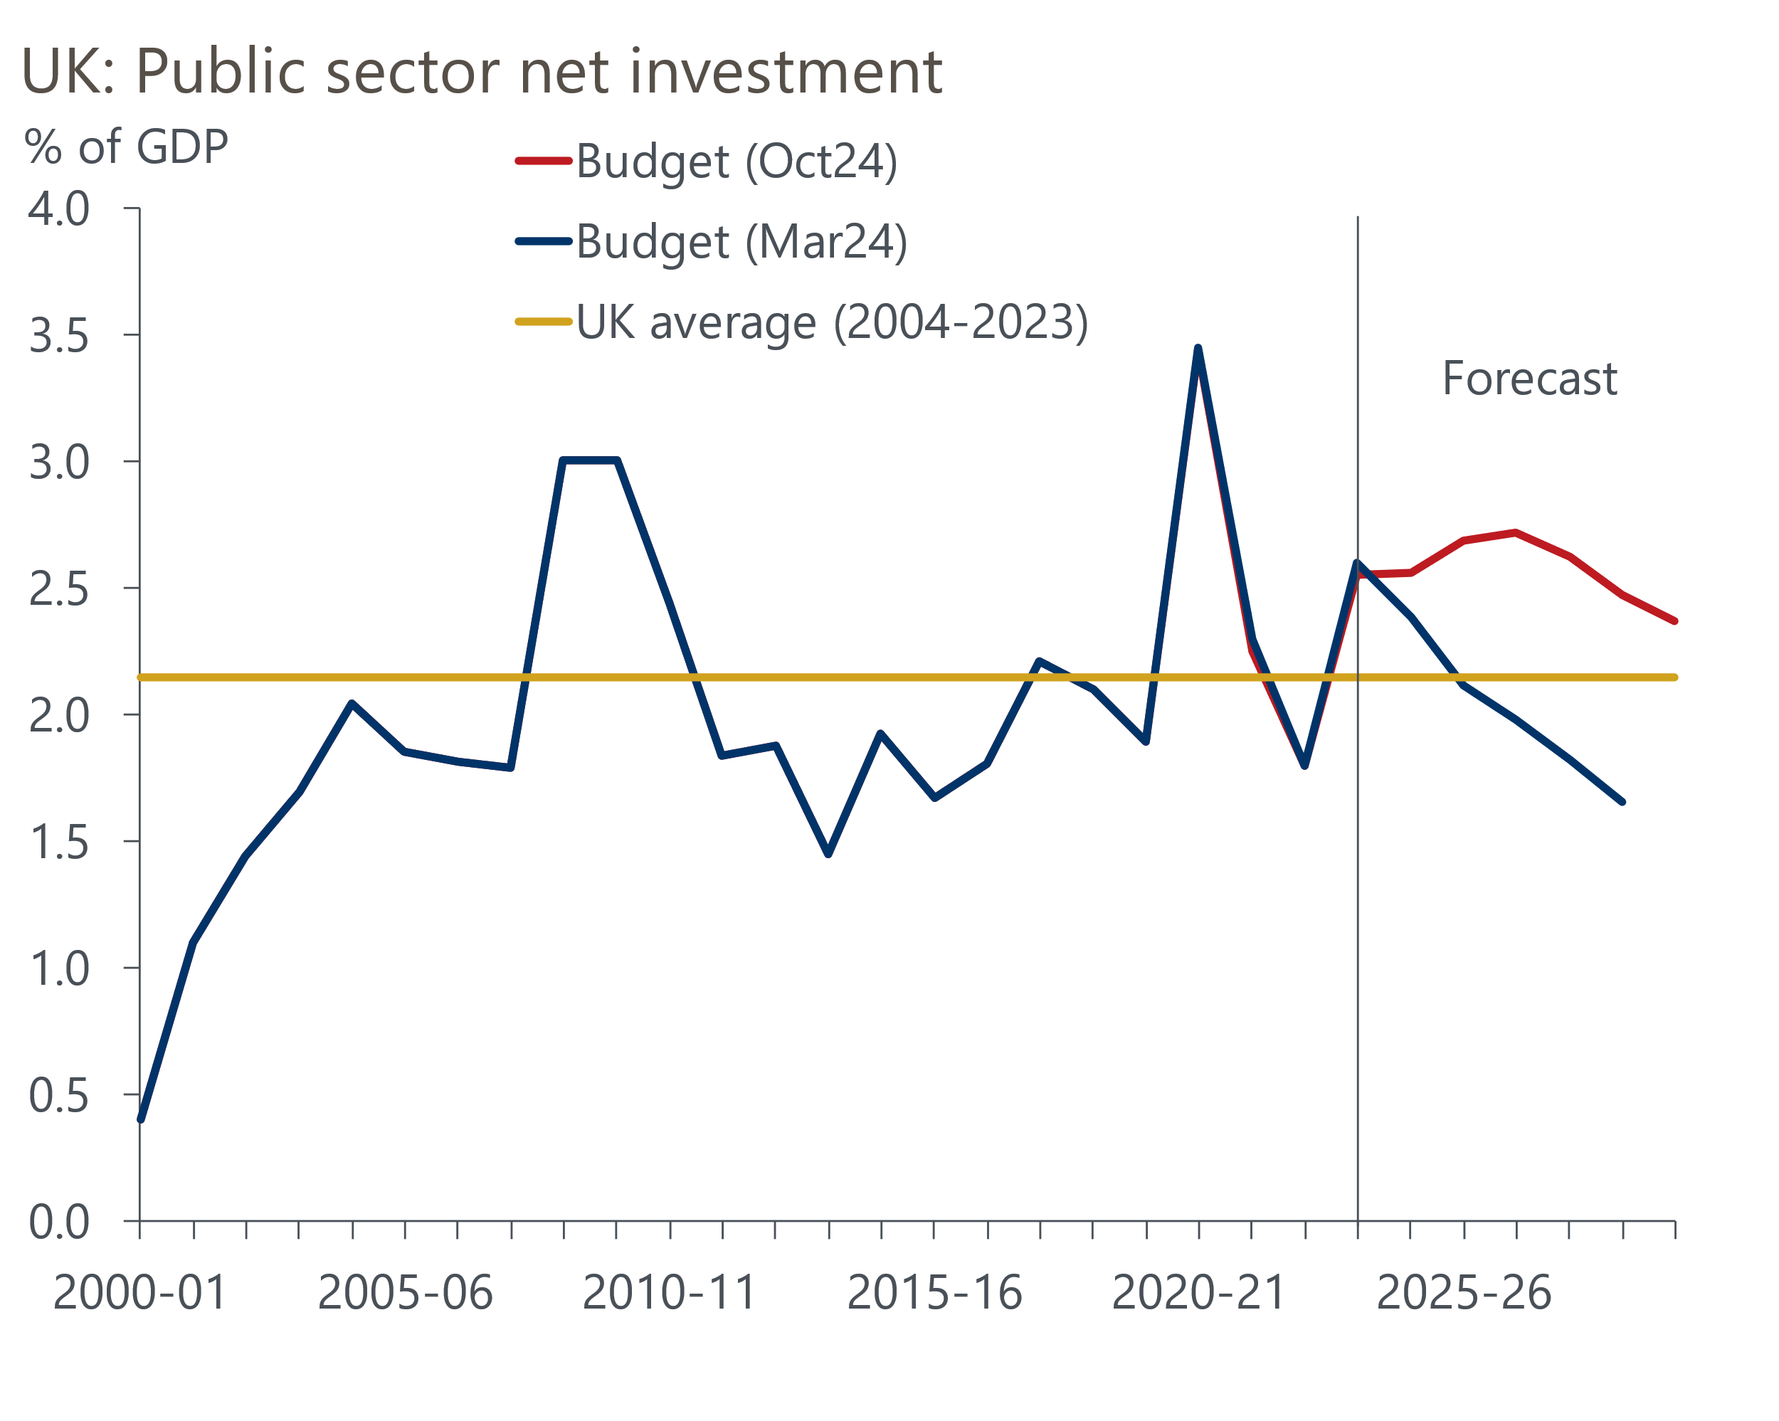
Sources: Oxford Economics, Office for Budget Responsibility
Higher public investment should offer a modest boost to potential output growth. Indeed, our modelling suggests that the OBR's recent paper on the impact of higher public investment on potential output might be too pessimistic. Academic literature also points to higher returns.
But the extent to which higher capital spending boosts the growth outlook will also depend on how the extra funding is allocated. Initially, plans appear to focus on fixing problems in existing infrastructure, such as crumbling school buildings. Longer-term ambitions around green energy and new transport infrastructure could have a more material impact on the long-term growth outlook, but mostly lack detail at this stage.

Companies bear the brunt of tax rises
The OBR's pre-policy measures forecast offered slightly more headroom against the new stability rule than before, reflecting an upward revision to its earnings forecast. But the change was small, and any increase in current spending had to be largely financed by higher taxation. The increase in tax was much higher than we had anticipated, with policy measures summing to £41bn (1.2% of GDP) in 2029-2030. Labour's manifesto had ruled out increasing most of the main taxes – sticking to that approach has meant that the burden of tax rises fell heavily on businesses.
Nearly two-thirds of the increase in tax will come from higher national insurance contributions from employers. The main rate of employers' NICs was increased by 1.2ppts to 15%, while the threshold at which companies must start paying was slashed to £5,000 from £9,100. The increase in employers' NICs was large partly to fund another freeze in fuel duty and to avoid extending the freeze in income tax and employee NICs thresholds, which already runs to 2027-2028.
While the increase in NICs is technically consistent with the government's promise to avoid increasing taxes on workers, the impact of higher employment costs will ultimately fall mostly on the workforce. We've run a scenario on our Global Economic Model that suggests the increase in employers' NICs will increase the level of unemployment by 0.2ppts after two years, with GDP and earnings being slightly lower.
The next biggest revenue raiser was £6.5bn from measures to tackle tax avoidance and reforms that will enable HMRC to collect a higher share of the revenue that it's owed. These revenues are highly uncertain and look an obvious source of slippage. Other announcements included an increase in the main rates of capital gains tax, reforms to inheritance tax, and the government following through on its manifesto commitment to abolish the 'non-dom' regime.

Current spending boosted but many departmental budgets will remain tight
The Chancellor opted to increase current spending by £51bn (1.5% of GDP) in 2029-2030, leaving a margin for error of just under £10bn against the new borrowing rule. A large chunk of the extra funding is the recurring element of the overspend identified by the Chancellor's review in July. The NHS will receive much of the remainder of the extra funding, while there was also extra money for defence and education. Departmental spending will now increase by an average of 1.5% a year in real terms, up from the previously planned 0.9%. But this will still mean that settlements are very tight outside of the protected departments.
The government will likely hope that the spending totals it has set today will be maintained. But there are risks of spending slippage in future years, or that either a lower tax take or lower potential growth will reduce the OBR's revenue forecast. Given the Chancellor has left such a small margin for error – similar to the very low levels typically left by her predecessor – this could mean that Reeves is forced to implement more tax increases in subsequent years.

Growth and implications for the BoE are not clear cut
The OBR concluded that today's measures will provide a net GDP boost of around 0.5ppts in 2025-2026 compared with the previous plans, with that support gradually withering away to zero in five years' time as the economy comes up against capacity constraints. But in absolute terms, policy will still be tightened over the next five years (Chart 4).
Our initial view is that the OBR is too optimistic about the extent to which output will be boosted next year. Much of the increase comes from higher government consumption, but higher public sector wages account for some of the increase in spending. The way that public sector output is measured also leaves us sceptical that output will be boosted to the extent expected.
Chart 4: The OBR estimates today's package will significantly lessen the squeeze this year
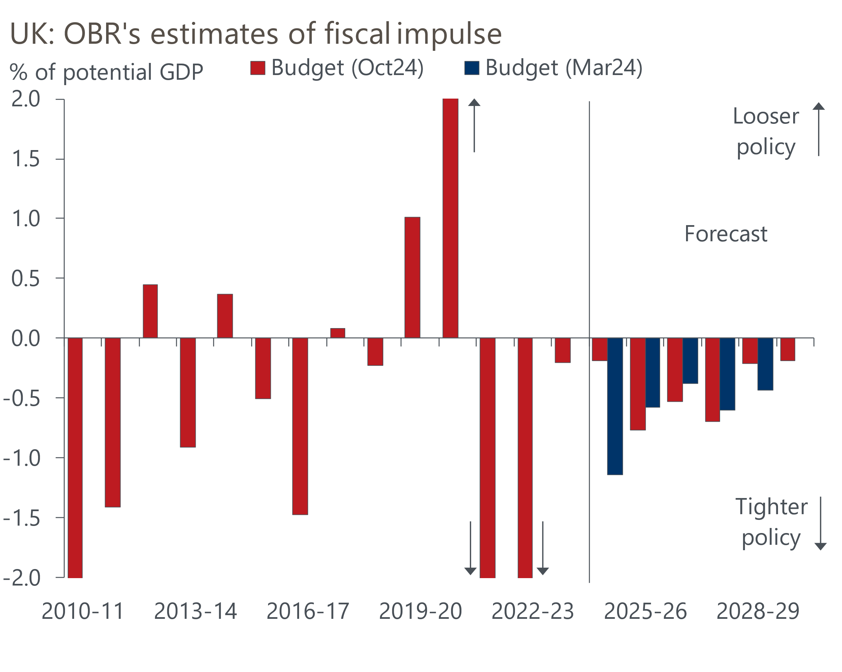
Source: Office for Budget Responsibility
It's unlikely that the Bank of England will be able to fully take on board today's decisions in the forecasts it will present in next week's Monetary Policy Report. But the bank's forecast will probably include a rough estimate of the effects of Budget measures, and the members of the Monetary Policy Committee will incorporate the Budget decisions into their thinking.
While there's nothing in today's announcements to throw a November 25bps rate cut off course, the implications for subsequent meetings are more ambiguous. If the MPC agrees with the OBR's verdict that GDP growth will be higher next year, this may make it harder to build a narrative that would justify faster rate cuts over the coming year. However, the MPC could still conclude that the growth/inflation trade-off has improved, and hence the improving inflation outlook will allow faster monetary loosening.

